ETHICAL HACKING ITA-1416
SLOT: B
REGNO. 192512417

1. Get-ComputerInfo Full system information
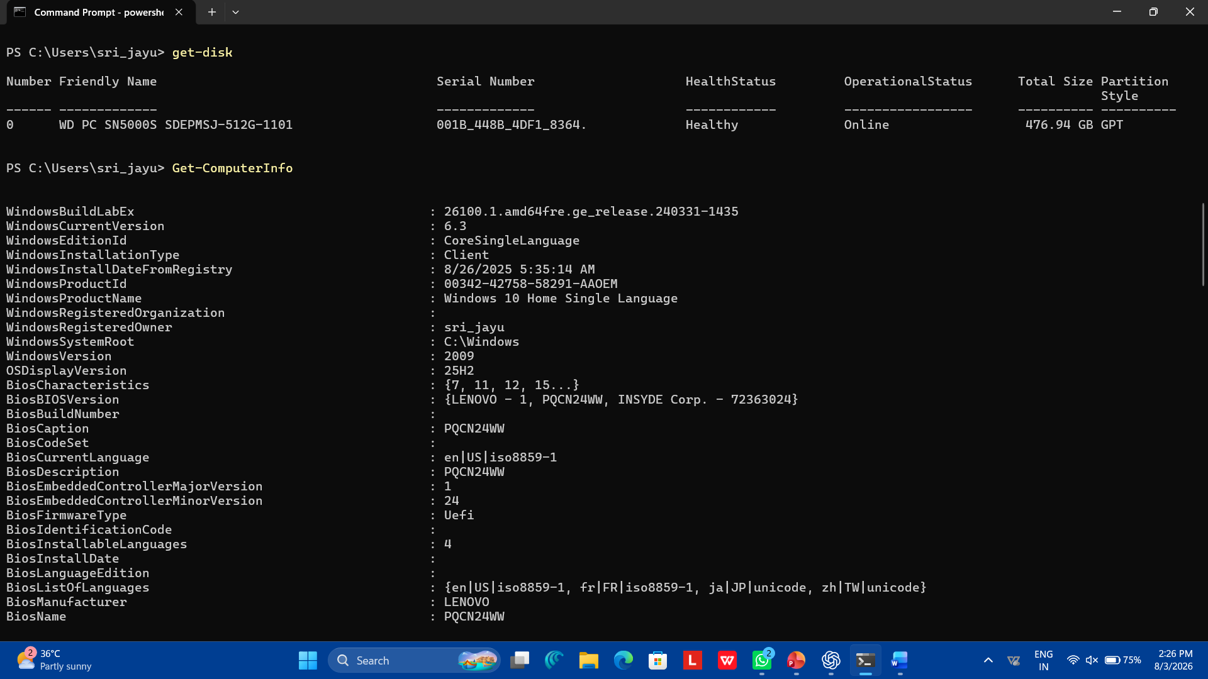

2. Get-CimiInstance Win32_OperatingSystem
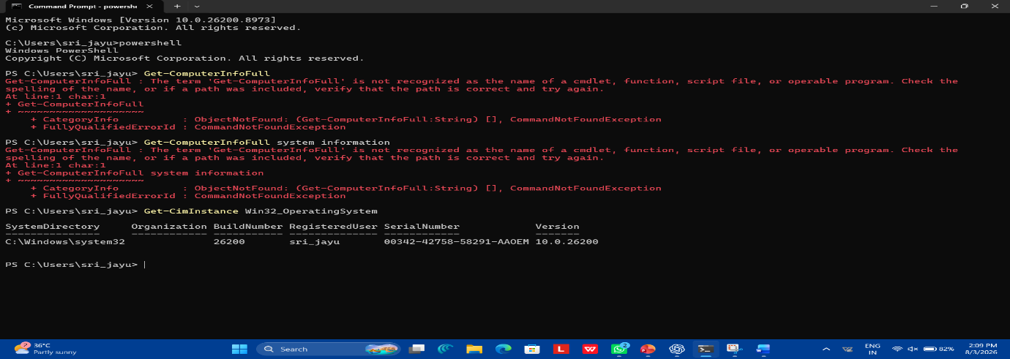

3. Get-CimInstance Win32_Processor
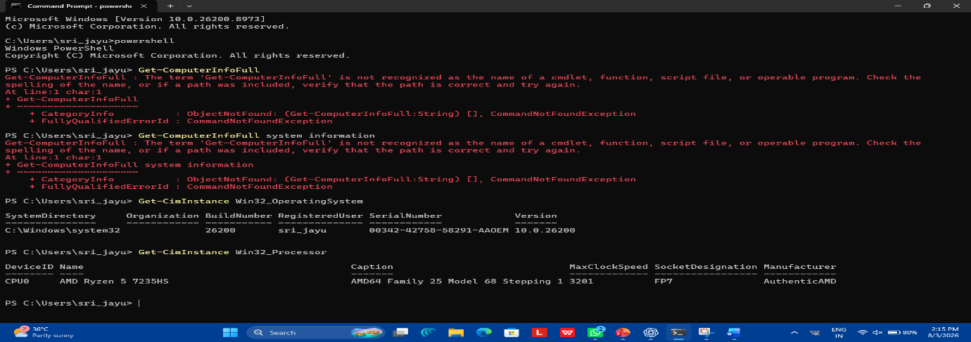

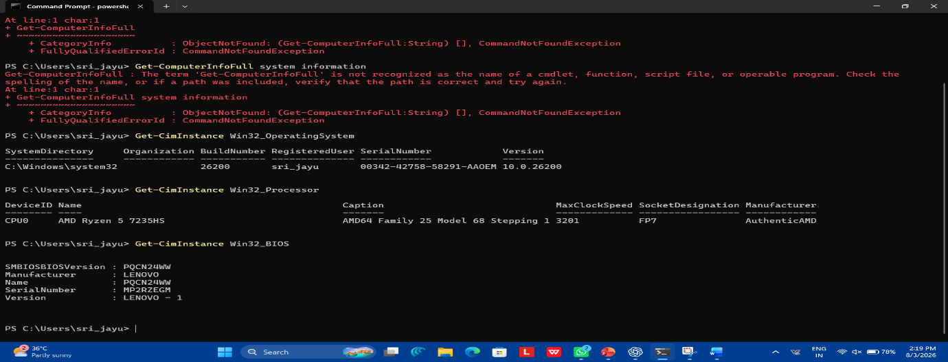
4. Get-CimInstance Win32_BIOS

5. Get-Disk
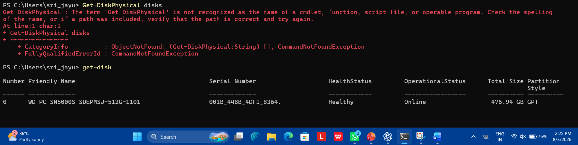

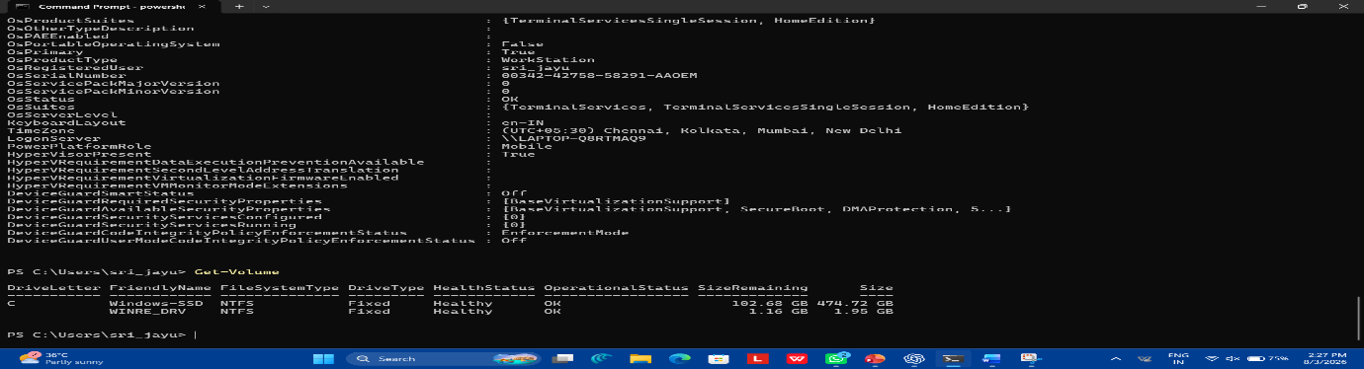
6. Get-Volume

7.Get-NetIPAddress
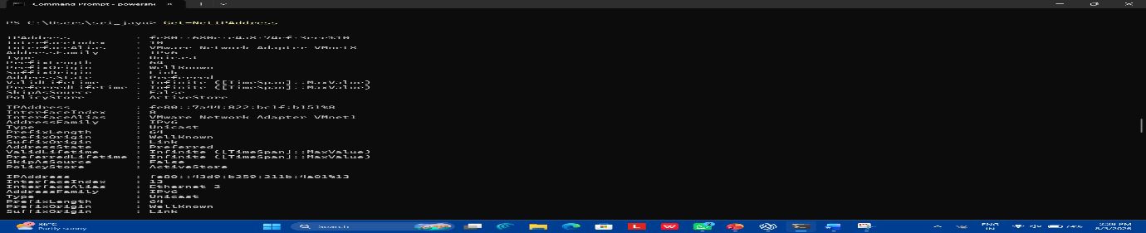

8. Get-NetTCPConnection

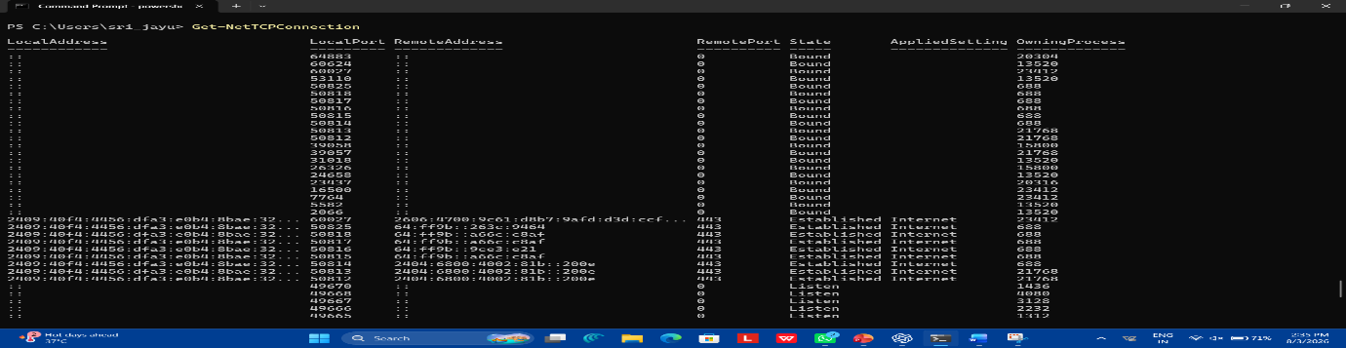

9. Get-NetAdapter

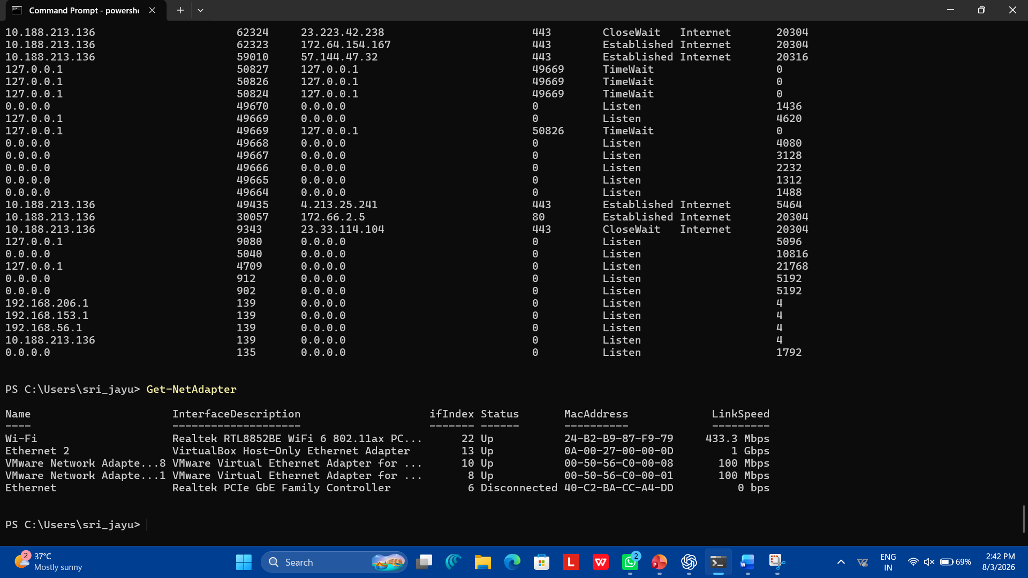
10. Get-Net TCP Connection

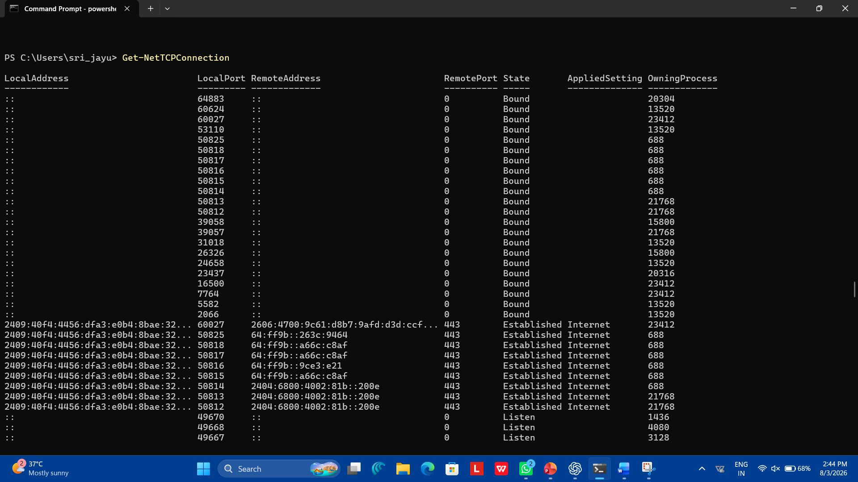
11. Get-NetIPAddress

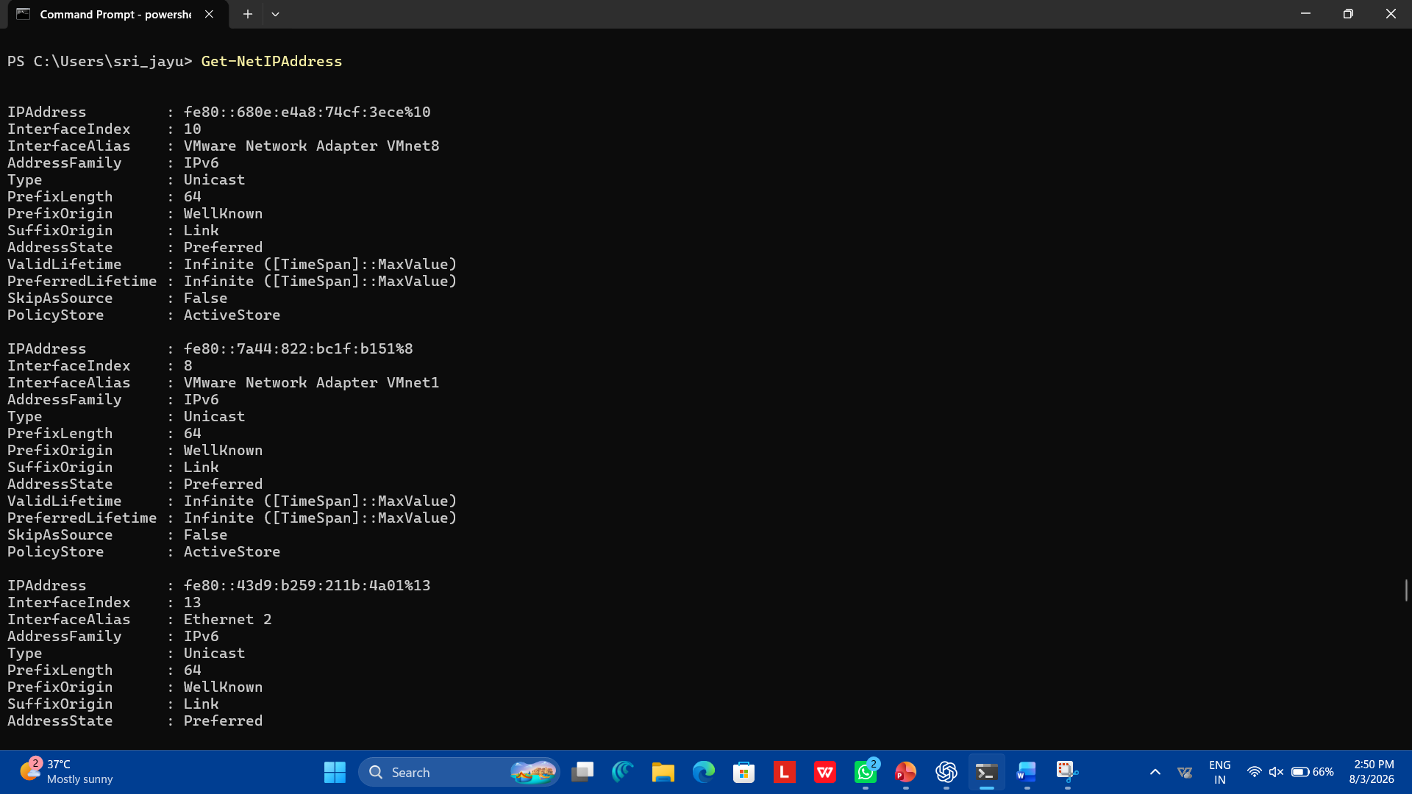
12. Get-Service
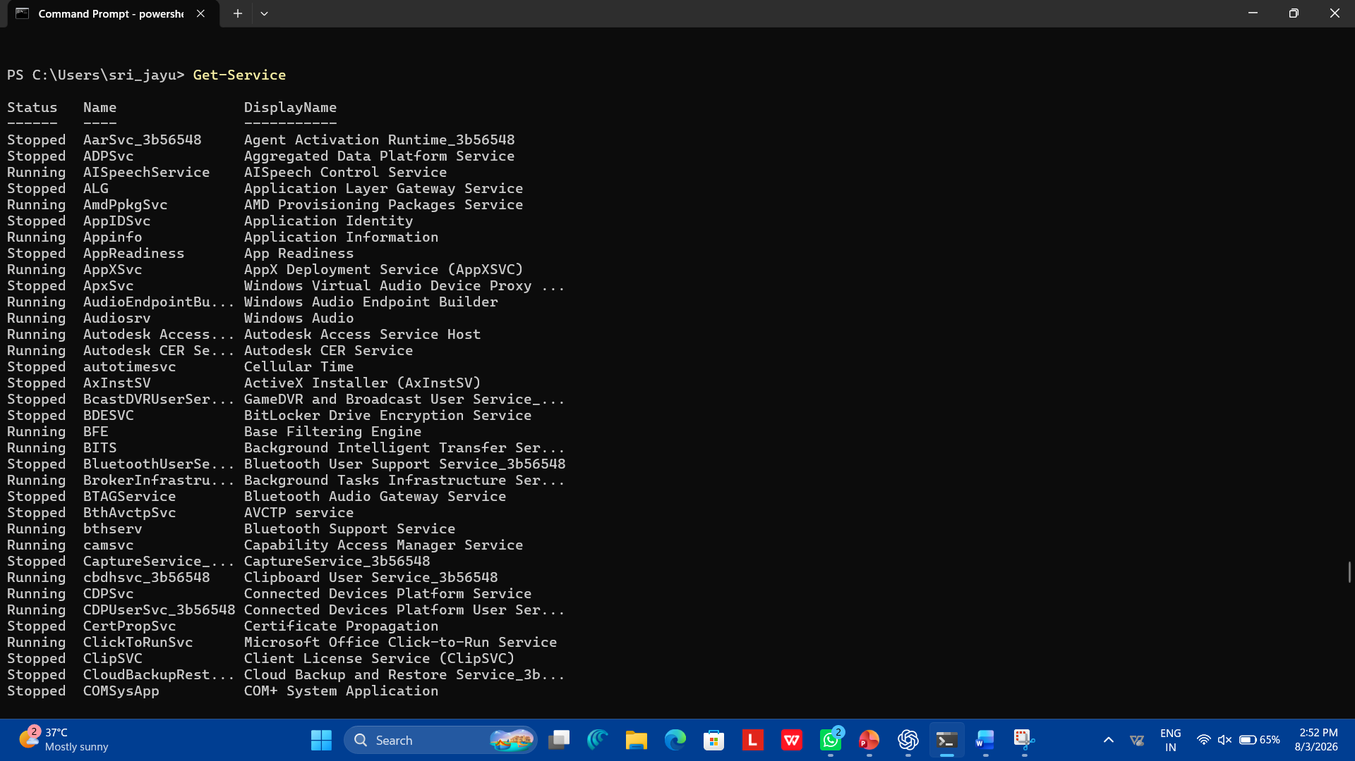
13. Get-LocalUser
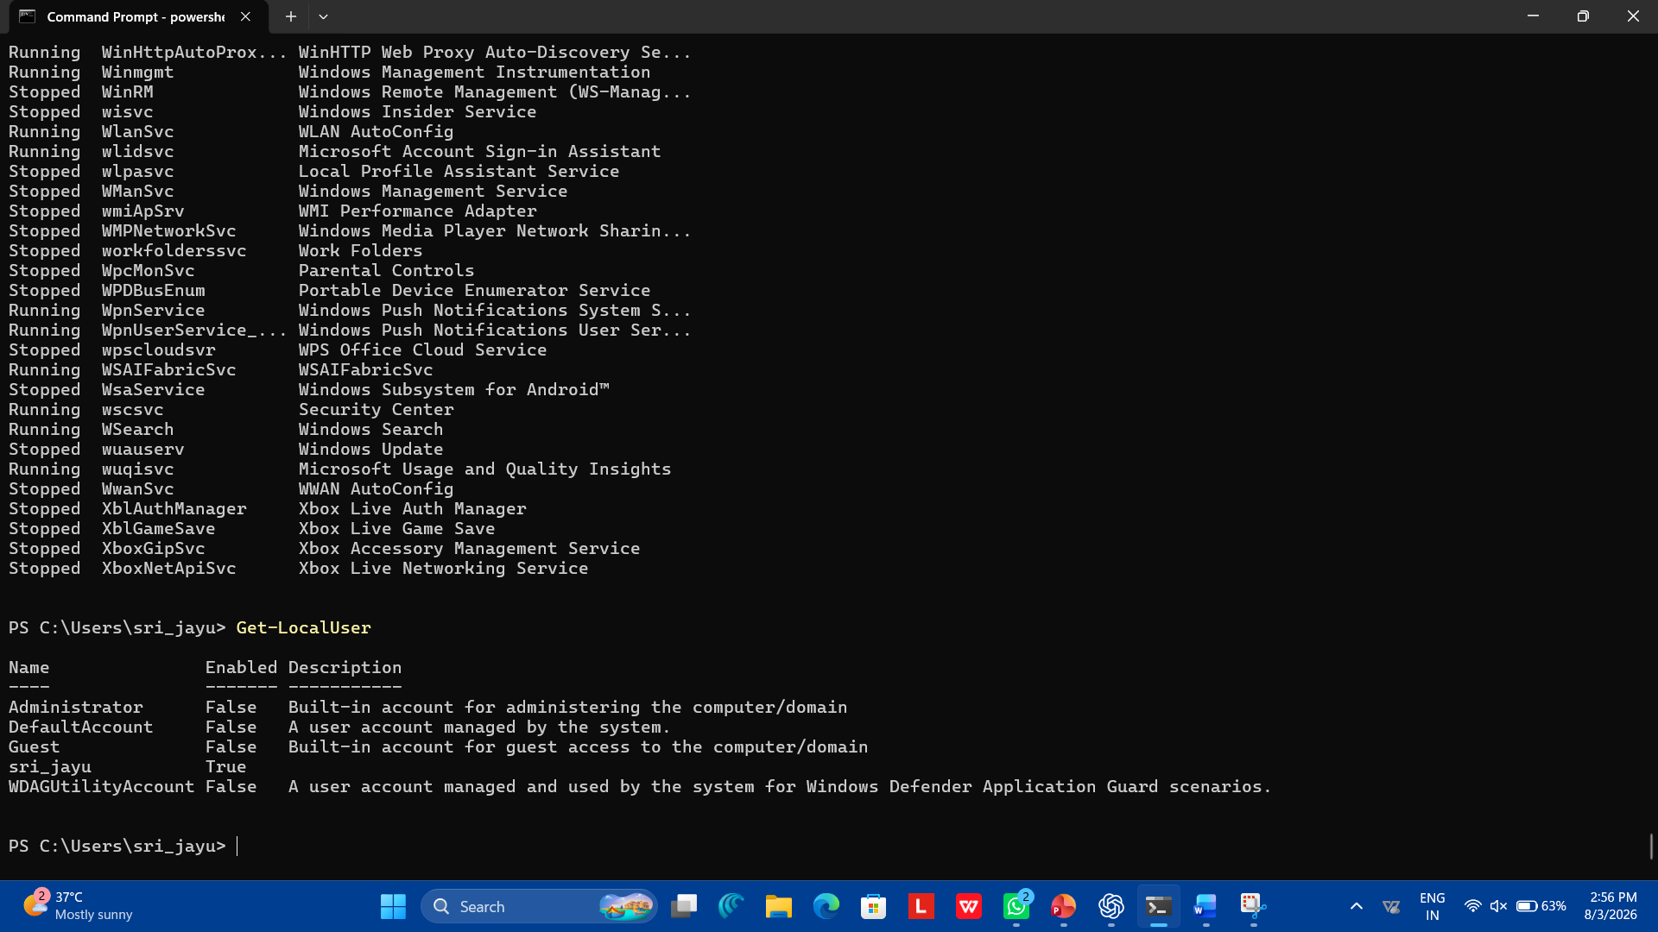
14. Get-LocalGroup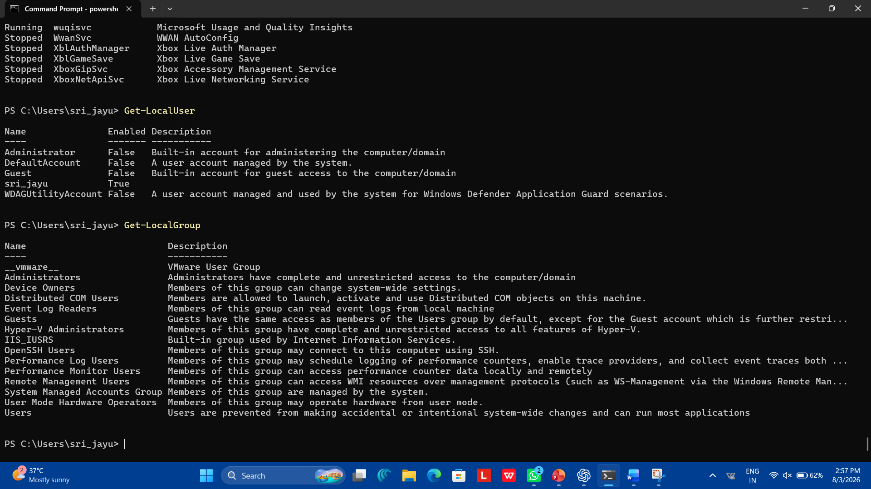

15. Get-LocalGroup
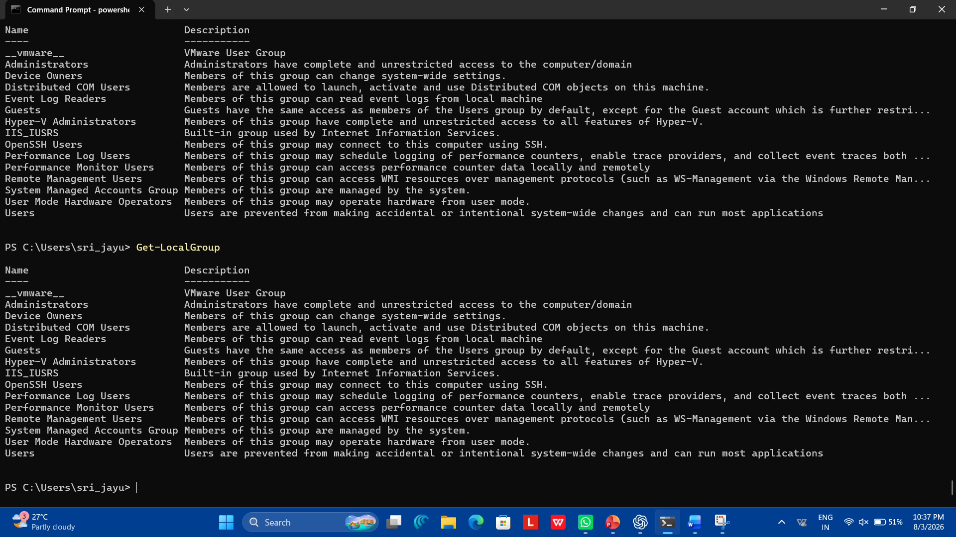
16. Get-HotFix
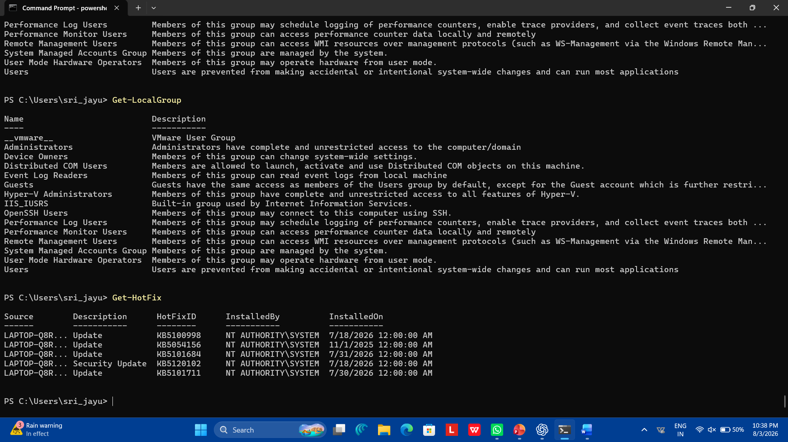
17. Get-ScheduledTask

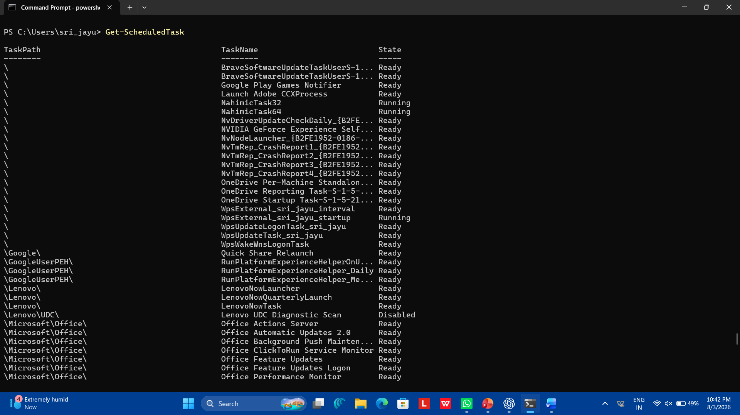
18. Get-MpComputerStatus
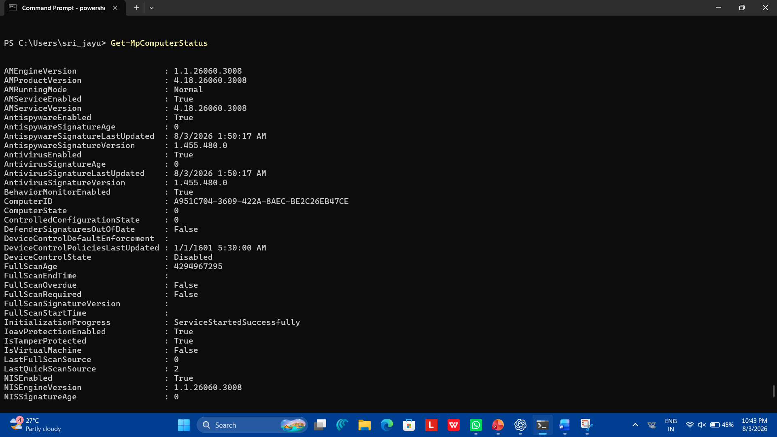
19. Get-NetFirewallProfile
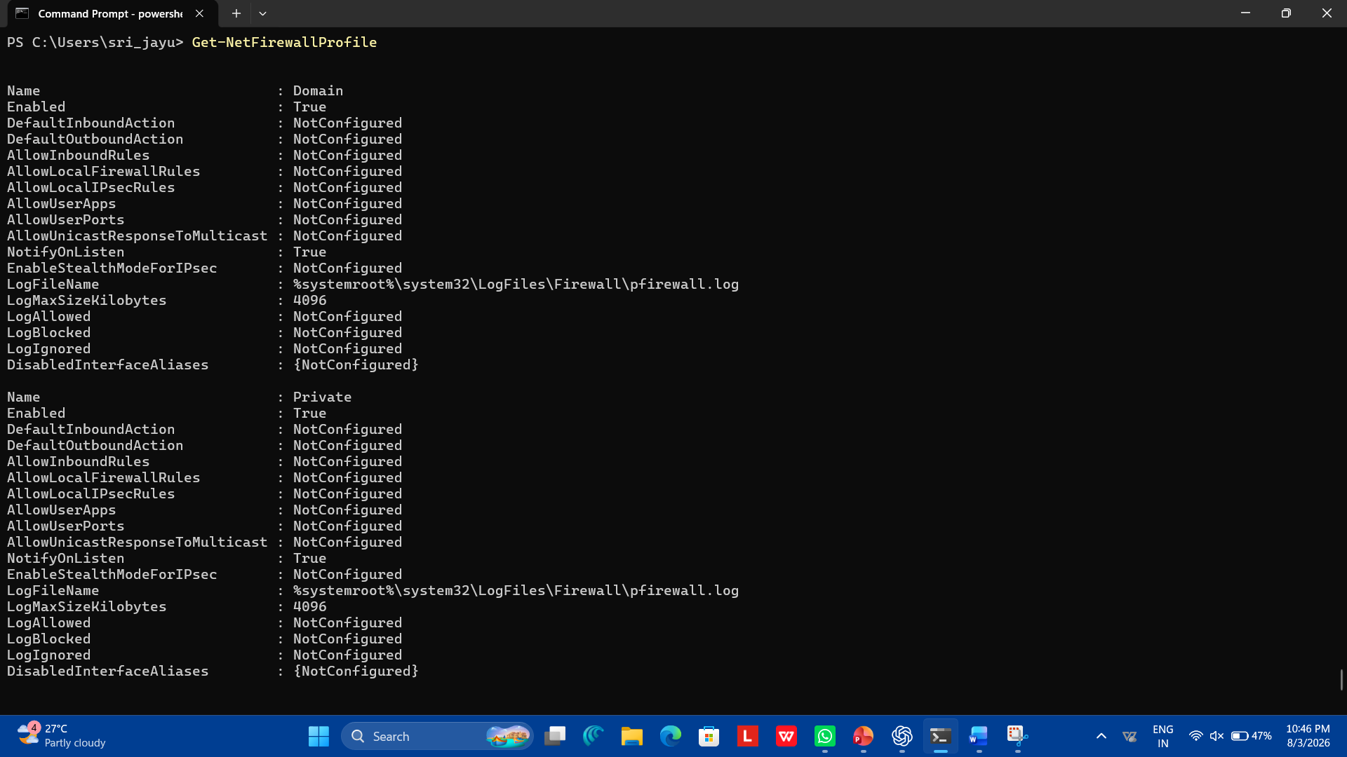
20. Get-ChildItem
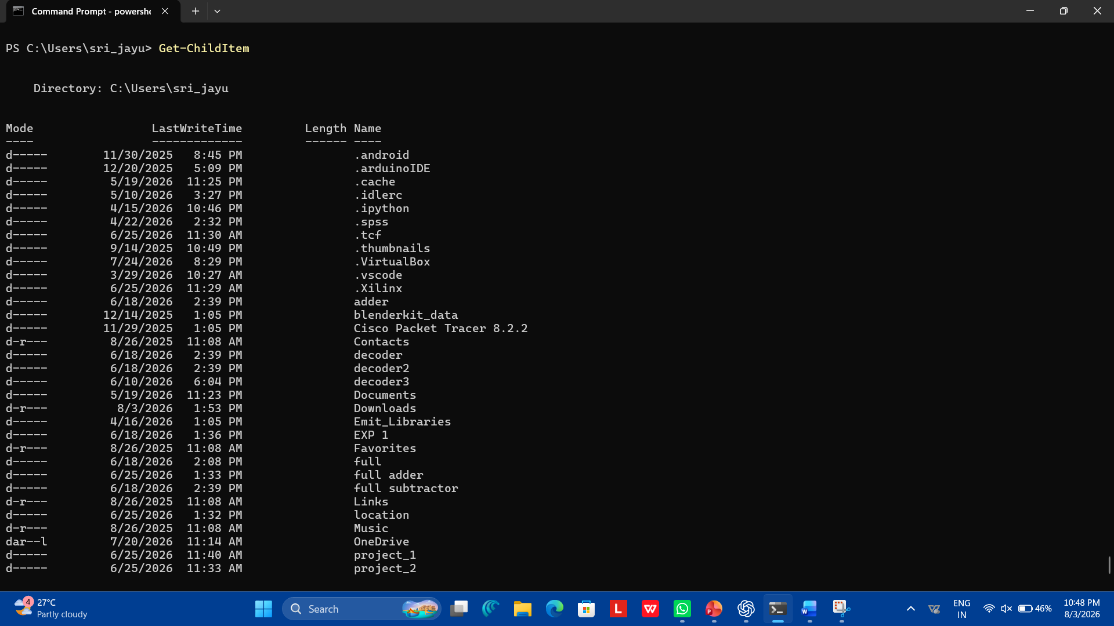
21. Get-WinEvent
